etrainu User Guide
Organisation

Table of Contents
Site Structure 4
Logging On 5
Switch Accounts 6
Manage Your Personal Account 7
Adding a New Participant 8
Managing Participants or Administrator Accounts 9
Editing a Participant or Administrator Account: 9
Removing a Participant or Administrator: 11
Removing Participants: 11
When an employee leaves the organisation you will need to remove their training partnership. A training partnership is the relationship between a student and their employer that manages their training records. Removing the training partnership will keep reports up to date. 11
Note: A training partnership can only be removed at the Sub Organisation level 11
Removing Administrators: 12
Viewing a Participant’s Training and Certificates: 14
Additional Participant Functions 15
User Documents 17
User-Records/Shared Documents 18
Training Key 20
Email 20
Allocating Training 22
Individual Training Key: 22
Bulk Assign Training: 24
Managing Departments 26
Manage Departments 26
Adding a New Department: 26
Removing a Department: 27
Managing Department Administrators 27
View Department Administrator: 28
Adding a New Department Administrator: 28
Managing Sub-Organisations 31
Manage Sub-Organisations 31
Adding a New Sub-Organisation: 31
Removing a Sub Organisation: 32
Managing Sub-Organisation Administrators 34
View a Sub Organisation Administrator: 34
Adding a New Sub-Organisation Administrator: 35
Participant Groups 38
Adding a New Participant Group: 38
Adding Participants to a Participant Group: 39
Removing Participants from a Participant Group 41
Deleting a participant from the Store Managers, Sales Assistant, Head office Managers, Head Office Non Managers or All Store Employees Participant group: 41
Managing Training Groups 43
Creating Training Groups: 43
Removing Courses from Training Groups: 45
Archiving Training Groups: 46
Viewing Reports 48
Training Status Report: 48
Participant Report: 50
Bulk Course Distribution Report: 52

Site Structure
Etrainu is designed to mimic a business’ organisational structure, where it focuses on a business’ reporting frameworks.
There are three levels of management who oversee the progress and advancement of individual participants. Each level of management can oversee all levels below but not those above it. For example, if you are a Department Administrator, you only have viewing rights to see records and participants within your department; you do not have access to other department’s records.
As an organisational administrator, you have the highest level of viewing rights; therefore you can see all records across your entire organisation.

Logging On
- Go to the website: http://www.etrainu.com
- Click on “Log In”
- Type in your Administrator username and password, and then click “SIGN IN”.
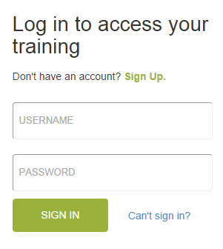

If you are having issues signing in and you have a vaild email address associated with your account simply click on “Can’t sign in?” and follow the prompts to reset your password.

Switch Accounts
This feature allows you to switch between your Administrator accounts (where you manage training and staff) and your Participant account (where you complete training modules) if you have one. The benefit of the Switch Accounts feature is that you only need to remember one username and password to switch between your accounts.
- Once you have logged into your account (if it hasn’t automatically taken you to the Home page), click on “Home” located in the top menu bar.

- Under the Welcome heading you will see all the accounts that you can switch between. Click on the “switch” button next to the account you wish to access.
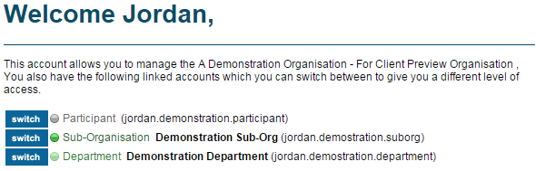

- Once you have switched to a different account, you will notice that your username has changed in the top right hand side of the menu bar – this is the best way to check which account you are in.

Manage Your Personal Account

Within this area of the website you can edit your personal account information. It is important that this information is current and up-to-date.
To view / update your personal user details in the system, complete the following steps:

- Click on “Account”
NB: If you have switched accounts it will have your username not account
- Click on “Edit Account”
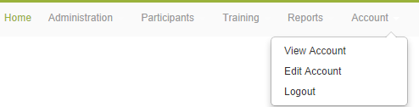
- Make any relevant changes / updates

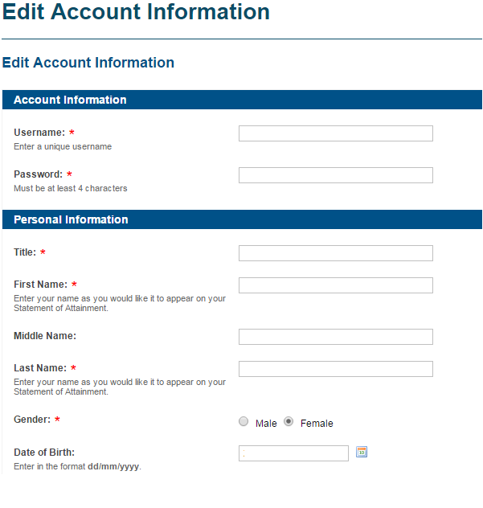

- Click “Next”
NOTE: All fields marked with a red asterisk (*) is required information.

Adding a New Participant
Each staff member in your organisation will need their own participant training account to access and complete training. Staff members, employees or students are all referred to as ‘participants’ in the etrainu Learning Management System (LMS). So when adding a ‘new participant’ into the LMS, you are simply adding a ‘new staff member’ so that they have an account to access online training.

- Click on “Participants” located in top menu bar – a drop down menu will then appear.
- Click on “Add Participants” from the drop down menu.
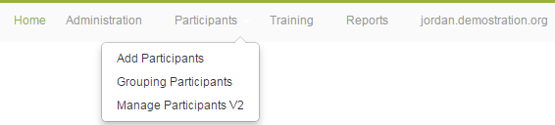
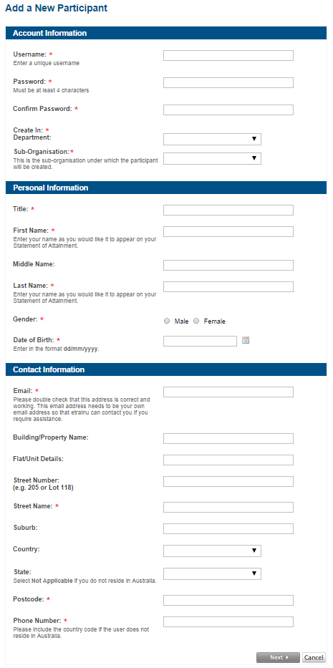
- Choose a username and password for the participant.

- Fill in the remaining fields with the participant’s details and click on “Next” to complete the form.

NB: All fields with a red ‘*’ are mandatory fields and must be completed. It is recommended that you enter a valid email address as an automated email is sent upon registration which contains the participant’s username and password for their reference.

Managing Participants or Administrator Accounts

Editing a Participant or Administrator Account:

Once a participant or administrator for a store has been entered into the system you can edit their account details. These instructions show the process for updating a Participant account (used for accessing training). However, if you would like to edit an Administrator account in your organisation, all you need to do is select the “Admins” user type.

- Click on “Participants” located in the top menu bar – a drop down menu will then appear.
- Click on “Manage Participants V2” in the drop down menu.
- Enter all search criteria in to the fields to help the system locate the account.
Set ‘User Type’ to ‘Participants’.
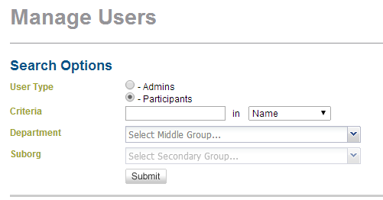
Enter the participant’s name, email or username in the ‘Criteria’ field ensuring to change the dropdown menu.
Select ‘Name’, ‘Email’ or ‘Username’ from the drop down menu.
Optional: To narrow down the results select the department and/or sub-organisation if known.
- Click on “Submit” – the system will then search and the account will appear on your screen.
- Click on the Edit iconnext to the participant’s name.

NB: If you are unable to find an employee in your search, they may not have been created under your organisation. Therefore, that person’s training account will not have a ‘partnership’ with your organisation that allows you to view their training profile. If so, please email helpdesk@etrainu.com for assistance.
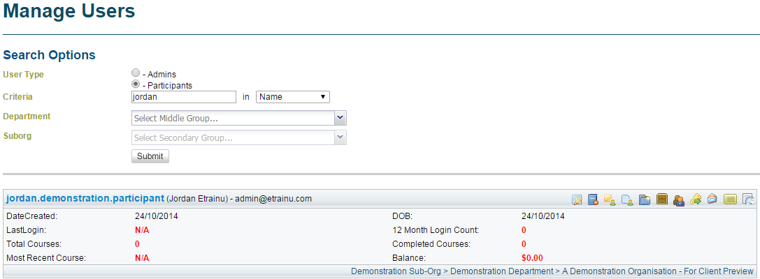

- Update the participant’s details, and then click “Next” to save them.

Removing a Participant or Administrator:

Removing Participants:

When an employee leaves the organisation you will need to remove their training partnership. A training partnership is the relationship between a student and their employer that manages their training records. Removing the training partnership will keep reports up to date.

Note: A training partnership can only be removed at the Sub Organisation level

- Click on “Participants” in the menu bar, a drop down menu will then appear.
- Click on “Participant Partnerships” in the drop down menu.
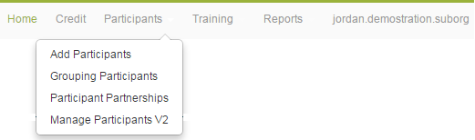
- Find the employee you wish to remove
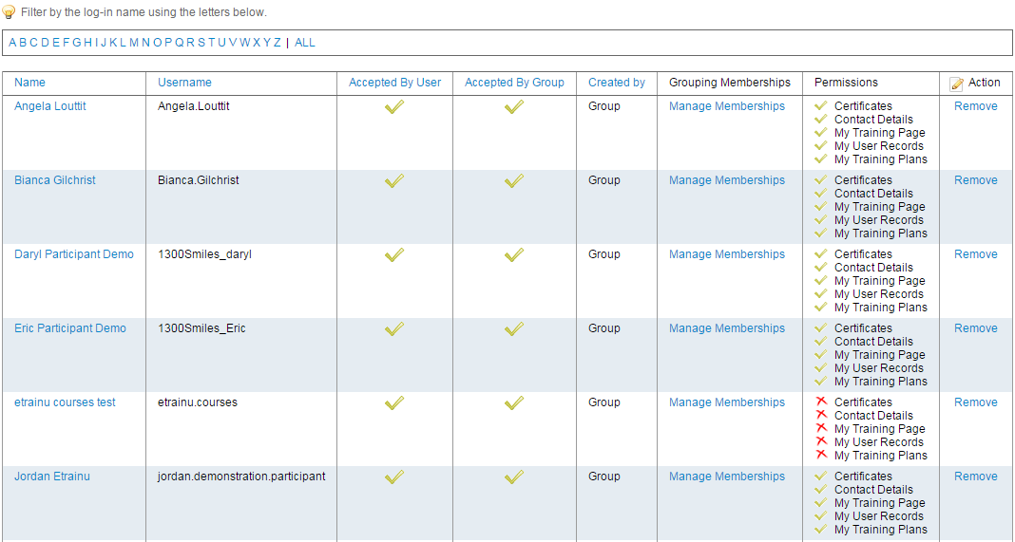
- Click on “Remove” from the action column
This employee is no longer associated with your sub-organisation. They will not appear on your staff list or reports.
NOTE: The student will remain on the “Training Partnerships” page.

Removing Administrators:

When an administrator leaves the organisation you will need to archive their account/s which will automatically cease all administration access to the LMS. These instructions show the process for archiving an Administrator account (used to set participant up and allocate training).

- Click on “Participants” in the menu bar, a drop down menu will then appear.
- Click on “Manage Participants V2” in the drop down menu.
- Enter all search criteria in to the fields to help the system locate the account.
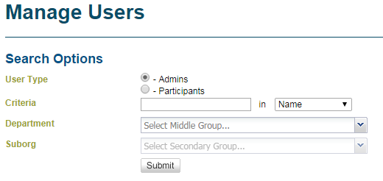
Optional: To narrow down the results select the department and/or sub-organisation if known.
Enter the administrator’s name, email or username in the ‘Criteria’ field ensuring to change the dropdown menu.
Select ‘Name’, ‘Email’ or ‘Username’ from the drop down menu.
Set ‘User Type’ to ‘Admins’.
- Click on “Submit” – the system will then search and the account will appear on your screen.

- If the search criteria are correct, the administrator/s with that information will appear under the Submit button. If they don’t, try changing your search options.

- Click on the Archive icon next to the administrator’s name to remove them from your organisation.
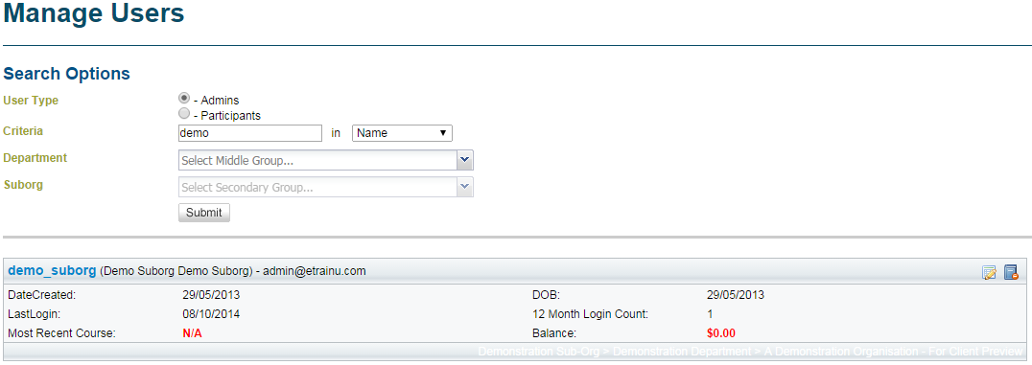
- A message will then appear that reads “Are you sure you want to archive this participant?” – If you are sure you want to archive them, the click on “OK”.

Viewing a Participant’s Training and Certificates:

You may access participant certificates or check the progress of a participant’s training.
- Click on “Participants” in the top menu bar – a drop down menu will appear.
- Click on “Manage Participants V2” in the drop down menu.
- Enter all search criteria in to the fields to help the system locate the account.
Optional: To narrow down the results select the department and/or sub-organisation if known.
Enter the participant’s name, email or username in the ‘Criteria’ field ensuring to change the dropdown menu.
Select ‘Name’, ‘Email’ or ‘Username’ from the drop down menu.
Set ‘User Type’ to ‘Participants’.
- Click on “Submit” – the system will then search and the account will appear on your screen.

- If the search criteria is correct, the participant/s with that information will appear under the Submit button. If they don’t, try changing your search options.
- Click on the View Training icon

- The following screen will appear with the training that has been allocated to that participant.
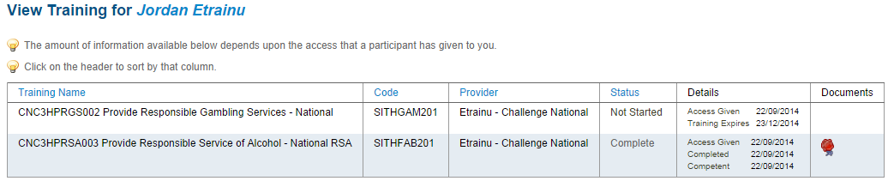
Click symbol to view certificate

Additional Participant Functions
You can manage a variety of functions for individual participants through the “Participants” drop down menu and also clicking on “Manage Participants V2”
User Notes
User Notes allow administrators to collect information relevant to an employee. User notes cannot be removed from a staff member’s account. They are not viewable by the participant.

Add/ View User Notes:
- Click on “Participants”
- Click on “Manage Participants V2”
- Locate the employee you wish to view notes on. You can do this by clicking on “Search” to bring up all participants or entering the name of the participant in the search bar first.

Optional: To narrow down the results select the department and/or sub-organisation if known.
Enter the participant’s name, email or username in the ‘Criteria’ field ensuring to change the dropdown menu.
Select ‘Name’, ‘Email’ or ‘Username’ from the drop down menu.
Set ‘User Type’ to ‘Participants’.
- Click on the “User Notes” icon associated with that employee
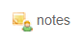
- To add a user note type in the area provided then click “Save”
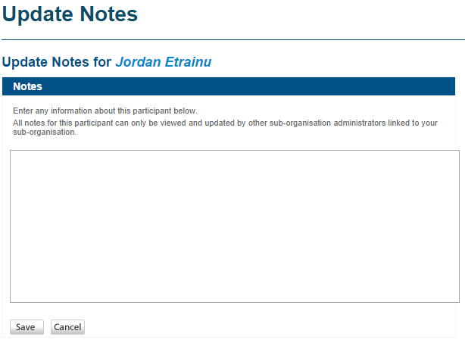
Type details of the note in this space
A record of all previous user notes can be previewed below the Save button.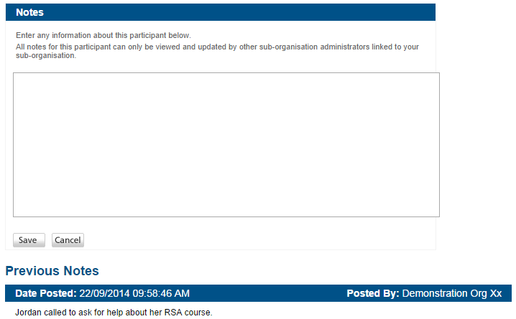
Previous User Notes, date posted and by whom

User Documents
User documents are any additional documents that the department administrator or sub-organisation administration would like to associate with a participant; such as notes on absenteeism or excellent employee behaviour in the workplace.
The participant cannot view user documents loaded by an administrator.

Add / View User Document
- Click the “User Document” image against the participant you wish to assign the document
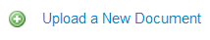
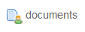
- Click “Upload a New Document”
- Give the document a title
- Upload the document by selecting the “Choose File” button, locate the file from your hard drive
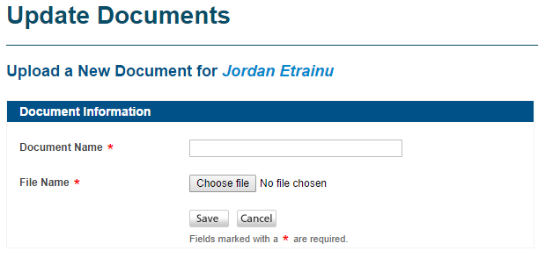
- Once you have selected the document for upload, click “Save”.

User-Records/Shared Documents
User-records can be created by employees and staff members. User-records can be removed from a participant’s file. A participant cannot view a user-record created by an administrator.
NOTE: if you wish an employee to see a user-record, the administrator can create a “shared user-record”. A shared user-record is viewable by both the administrator and the participant.

View User-Records/Shared Documents
- In the Participants/Manage Participants V2 tab, locate the employee you wish to view the user-records for
- Click on the “User-records” icon associated with that employee
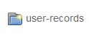

Add a User-Record
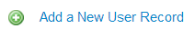
- Click on the “User-record” icon next to the staff member’s name
- Select “Add a New User Record”
- Enter the record name, details and if necessary upload a PDF document from your files then click “Save”.
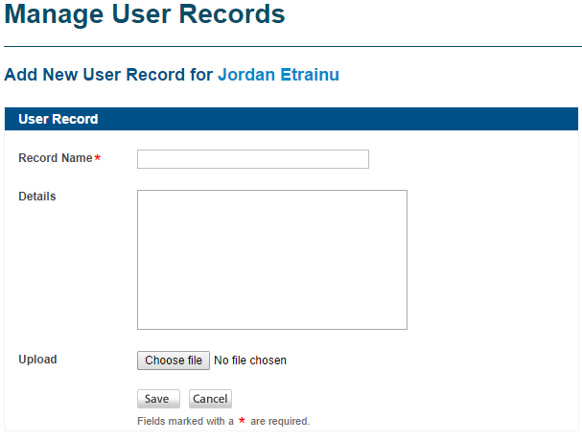

Remove a User-Record
- Click on the “Archive” icon next to the user-record you wish to remove
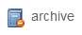
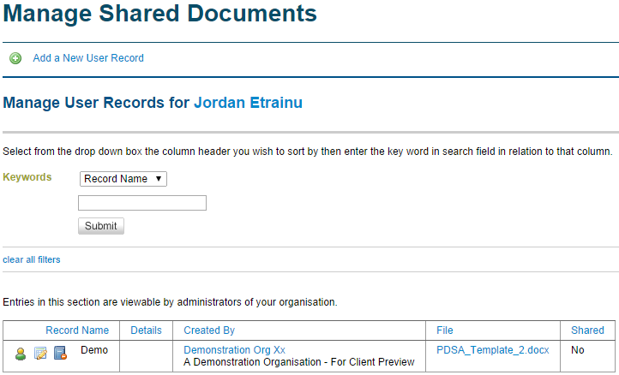

Training Key
As explained in the generating training keys section of this manual, this icon allows you to assign training to the individual staff member.
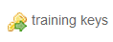

Email
The email functionality allows you to directly email a participant. The email is recorded against the participant’s file for the life of their employment with you. You can refer to these emails at any stage.
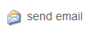
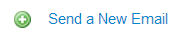
- Click the “email” icon against the participant you wish to contact
- Click “Send a New Email”
- Fill out all specified fields (all fields marked with an asterisk )
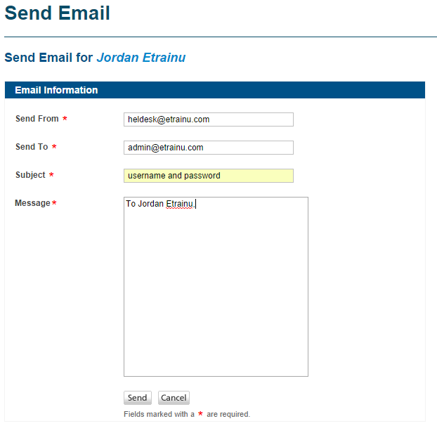
- Click “Send”

A record of all emails sent to a participant is saved in this email area. Only administrators and the relevant employees are able to view these emails.

Allocating Training
In the etrainu LMS, each training module has its own unique ‘Training Key’. When a Training Key is allocated to a participants’ account, it gives them access to that particular module. Assigning Training Keys (modules) to an employee or group of employees is relatively simple.
Training Keys can be assigned in two ways:
- Individual training allocation (to an individual employee)
- Bulk training allocation (to a group of employees)

Individual Training Key:

- Click on “Training” located in the menu bar – a drop down menu will then appear.
- Click on “Assign Training” in the drop down menu.
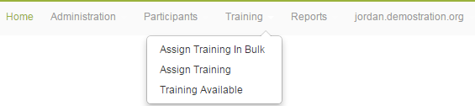
- Enter the participant’s name or username in the space provided, and then click on “Search”.

- Click on the Training Key icon
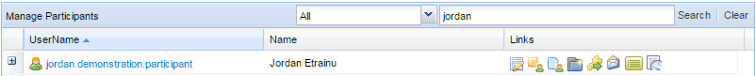
- Click on the Course Category that the training module you wish to allocate sits under. Course Categories group training modules into categories so that they are easier to locate.

- Find the module or bundle of modules that you wish to assign to the participant and then click on the button to allocate the course to their account.
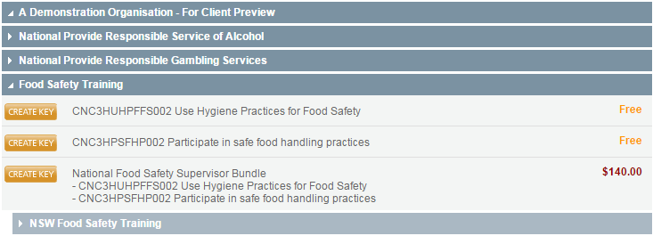
- If there is a cost associated with the training, it will take you to the cost confirmation page. If you have sufficient credit simply click confirm. If you do not have sufficient credit in your account please refer to Purchase Credit instructions.

- Once you have allocated a module (or bundle) to a participant, they will then receive an automated email with the course information, and can commence their training immediately.

Bulk Assign Training:

If you would like to assign the same training module (or bundle) to multiple employees, you can use the “Assign Training in Bulk” function.

- Click on “Training” located in the top menu bar – a drop down menu will then appear.
- Click on “Assign Training In Bulk” in the drop down menu.
- Click on the relevant Course Category, and then locate the module or bundle you wish to allocate.

- Click on the “select” button next to the module or bundle – a list of available participants will then load on your screen. If a participant already has the module or bundle of modules, they will appear in grey.
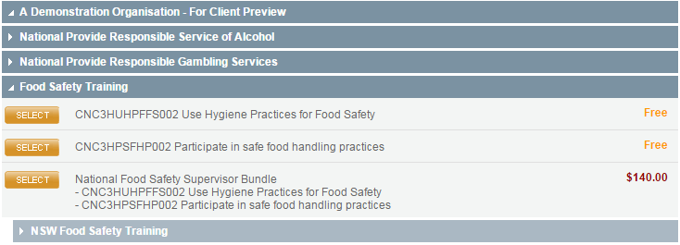
- Select the participants or participant group/s you wish to assign the Training Key to.
NB: If you want the employees to receive an email to inform them they have been allocated training, then select the “Send New Key Email Notification” checkbox.
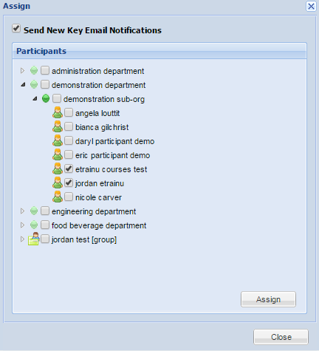
- Click on “Assign”.

- Once the page loads, double check that the list of participants is correct, and then click on “Confirm” to process the bulk assign.
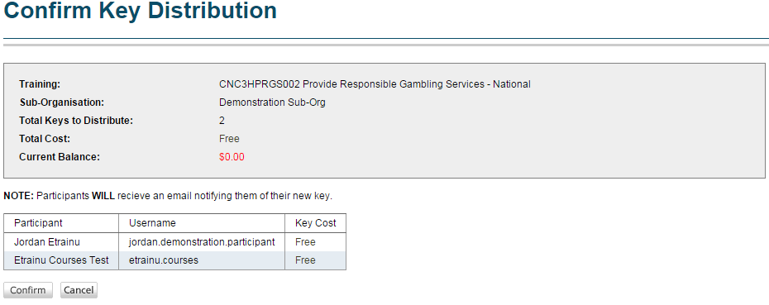
NB: When you allocate a module or bundle to participants using the bulk assign function, it will take over night for the training to appear in their training profiles.

NB: If there is a cost associated with the training, it will take you to the cost confirmation page. If you have sufficient credit simply click confirm. If you do not have sufficient credit in your account please refer to Purchase Credit instructions.

Managing Departments

Manage Departments
The ‘manage departments’ feature allows you to view and edit the structure of your organisation in the etrainu LMS, as well as edit the Administrators for each level.
The Administrators that are setup at a particular ‘level’ will only have access to view and manage the training and participants from that department or sub-organisation.
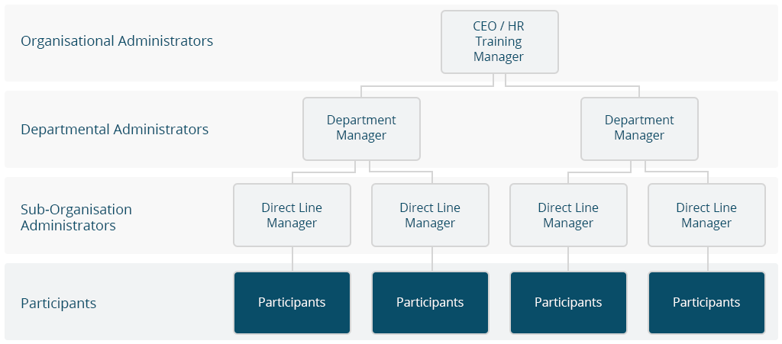

Adding a New Department:
- Click on “Administration” located in the top menu bar.
- A drop down menu will appear – click on “Manage Departments”.
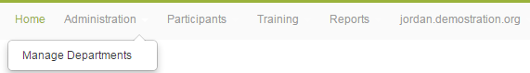
- On your screen, click on “Add a New Department”.
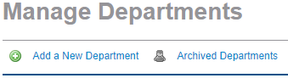
- Type in the name of the department and click “Save”.
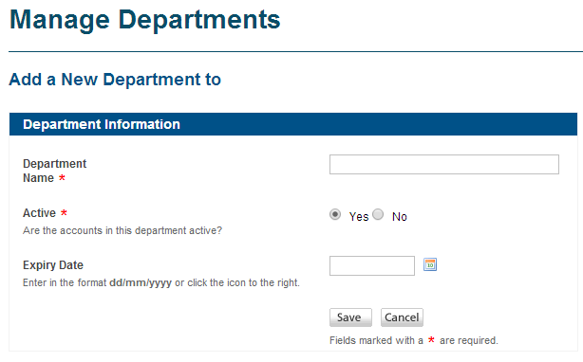
Select ‘Yes’ to activate the Department.
Enter the name of the Department.
By setting an expiry date this will deactivate all accounts below this department as of this date. All participants will be deleted from the system.

Removing a Department:
- Click on “Administration” in the top menu bar – a drop down menu will appear.
- Click on “Manage Departments” in the drop down menu.
- Locate the department you wish to archive and click the archive symbol next to the name.
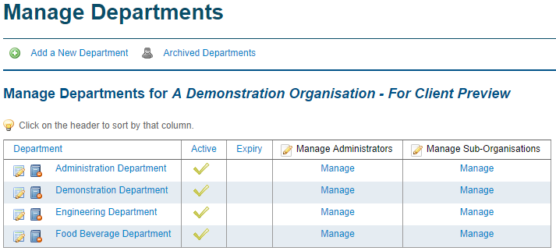

NB: By archiving a department all sub-organisations and participants under this department will also be archived.

Managing Department Administrators
By managing Department administrators, you are controlling who has access to oversee employees (participants) training progress across an entire department.

View Department Administrator:
- Click on “Administration” – a drop down menu will appear.
- Click on “Manage Departments” in the drop down menu.
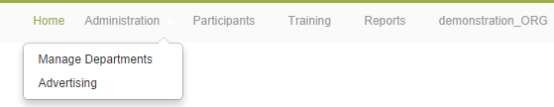
- Locate the Department of which you wish to view the Administrators.
- Click on “Manage” in the Manage Administrators column. This will show a list of Department administrators.

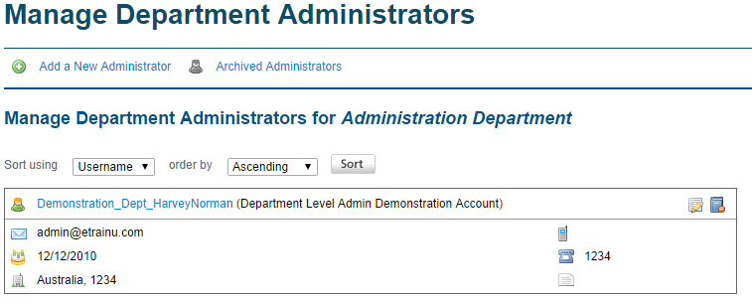
You can edit an administrator’s details by clicking the edit button. This will allow you to reset their username, password and any other personal information.
You may also archive an administrator’s account. The archive button will remove the administrator from the etrainu LMS. If you archive an administrator they will no longer be able to log in to etrainu as an administrator.

Adding a New Department Administrator:
A Department level administrator will oversee lower level participants and administrators who belong to that Department. A Department can have multiple administrators.
To add an administrator, complete the following steps:
- Click on “Administration” in the top menu bar – a drop down, menu will appear.
- Click on “Manage Departments” in the drop down menu.
- A list of Departments will appear on your screen. In the Manage Administrators column, click on “Manage” next to the relevant Department.
- Click on “Add a New Administrator”.
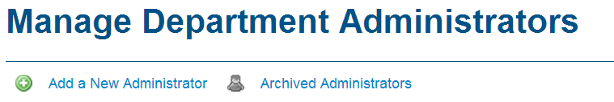
- Enter the details for the administrator, and then click “Next” to create that account.
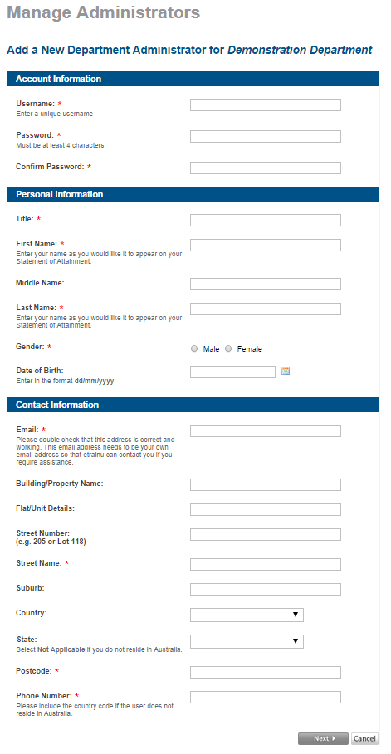
NB: Fields marked with a red (*) are mandatory fields.

Managing Sub-Organisations

Manage Sub-Organisations
A Sub-Organisation is a title given to the tier directly below a Department. A Sub-Organisation is the area that participants belong to (e.g. all employees of the W.Lane store in Bathurst). A Sub-Organisation can have multiple administrators to oversee participants. Each Department must have at least one Sub-Organisation below it.

Adding a New Sub-Organisation:
- Click on “Administration” in top menu bar – a drop down menu will appear.
- Click on “Manage Departments” in the drop down menu.
- Click on “Manage” in the Manage Sub-Organisations column, next to the Department you wish to place the Sub-Organisation underneath.
- Click on “Add a New Sub-Organisation”.
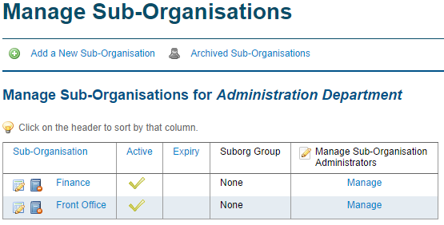
- Enter the information for the Sub-Organisation into the relevant fields, and then click “Save”.
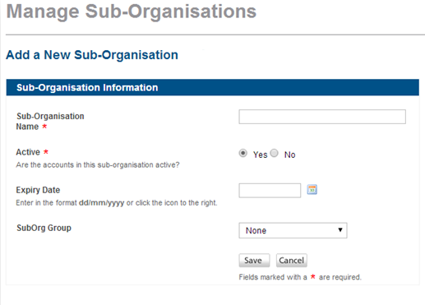
This will activate or deactivate all accounts below this department. For the sub-organisation to be used, it must be active.
By setting an expiry date this will deactivate all accounts below this department as of this date. All participants will be deleted from your organisation.

Removing a Sub Organisation:
Removing a Sub-Organisation will delete all administrators and participants (employees) within that Sub-Organisation.
- Click on “Administration” in the top menu bar – a drop down menu will appear.
- Click on “Manage Departments” in the drop down menu.
- Locate the Department that the Sub-Organisation is under, and then click “Manage” in the Manage Sub-Organisations column.
- Locate the Sub-Organisation you wish to archive, and the click the archive symbol next to the name.
NB: By archiving a Sub-Organisation all participants under this area will also be archived.

Managing Sub-Organisation Administrators
A Sub-Organisation may have multiple administrators to help manage participants.

View a Sub Organisation Administrator:
- Click on “Administration” in the top menu bar – drop down menu will appear.
- Click on “Manage Departments” in the drop down menu.
- Click on “Manage” in the Manage Sub-Organisations column next to the relevant Department.
- Click on “Manage” in the Manage Sub-Organisation Administrators column – a list of all administrators for this Sub-Organisation will appear.
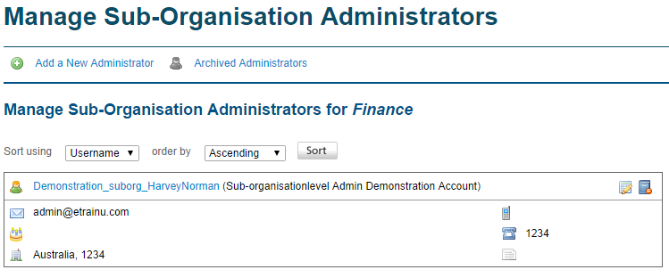

- You can edit an administrator’s details by clicking the edit button that allows you to re-set a username, password and any personal information of that administrator.
You may also archive an administrator’s account. This will remove the administrator from the etrainu system. If you archive an administrator they will no longer be able to login to etrainu as an administrator.

Adding a New Sub-Organisation Administrator:
Multiple Sub-Organisation administrators can be assigned to a Sub-Organisation. Those administrators may only oversee employees within their Sub-Organisation.
- Click on “Administration” in the top menu bar – drop down menu will appear.
- Click on “Manage Departments” in the drop down menu.
- Click on “Manage” in the Manage Sub-Organisations column next to the relevant Department.
- Click on “Manage” in the Manage Sub-Organisation Administrators column next to the relevant Sub-Organisation.

- Click on “Add a New Administrator”.
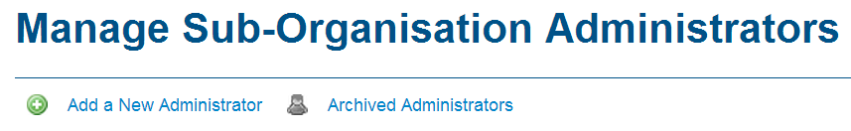
- Enter the details of the administrator you wish to create, and then click “Next” to create the account.

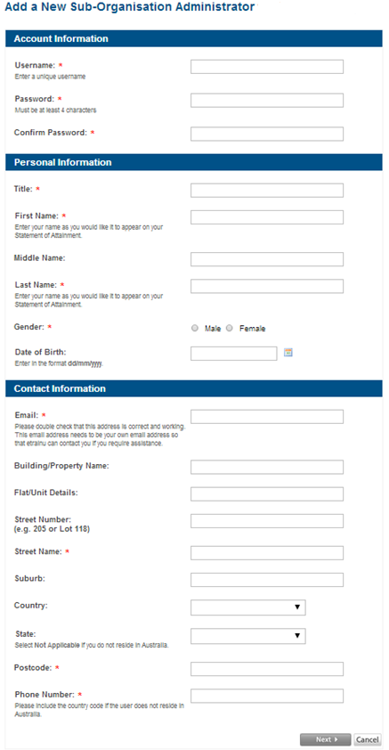
NB: All fields marked with a red asterisk (*) are mandatory.
Participant Groups
The ‘Participant Groups’ feature in the LMS allows you to group any employees within your organisation. Creating groups will allow you view training reports of an entire group of individuals (e.g. managers, sales assistants or region) as well as assign training in bulk to that group. From the Organisation level, you have the ability to add individual participants to groups as well as entire sub-organisations to a group.

Adding a New Participant Group:
- Click on “Participants” in the top menu bar – a drop down menu will appear.
- Click on “Grouping Participants” in the drop down menu.
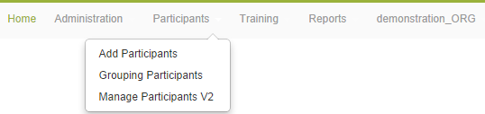
- Click on “Add a New Group”.
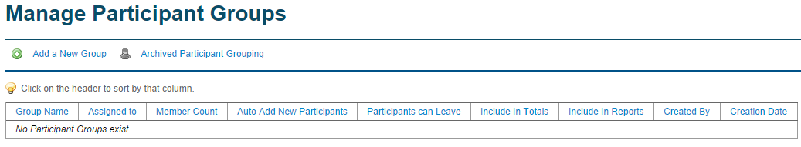
- Enter a name for the participant group and fill in the remaining details.
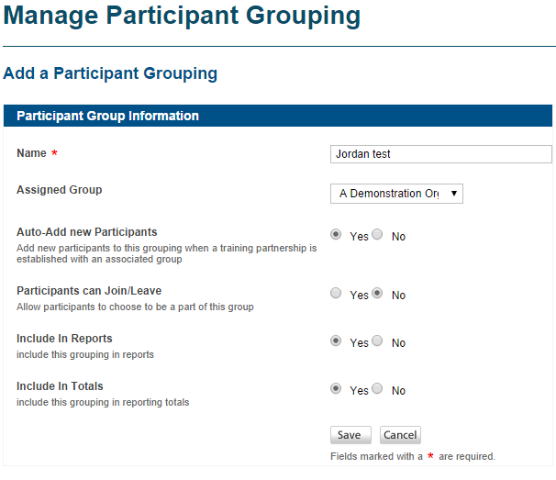
Ensure ‘Auto-Add new Participants’ is set to Yes.
Ensure ‘Participants can Join/Leave’ is set to No.
Ensure ‘Include in Reports’ and ‘Include in Totals’ is set to Yes.
Enter a name for the participant group.
Select the Organisation.
- Click on “Save”.

Adding Participants to a Participant Group:
When adding a Assigned Group (sub-org) to a participant group participants that you enter into the system that associated with that assigned group (sub-org) will automatically be added to the Participant Group.
You will however need to add Participants into the Store Managers, Sales Assistant, Head office Managers, Head Office Non Managers and All Store Employees groups. To do this, please follow the below steps:
- Click on “Participants” in the top menu bar – a drop down menu will appear.
- Click on “Grouping Participants” in the drop down menu.
- A list of participant groups will appear – locate the group and click on the Add icon
- Now the list of participants that are already assigned to that group will appear. Scroll down below this list and you see an Assign Users tab and Assign Groups tab.
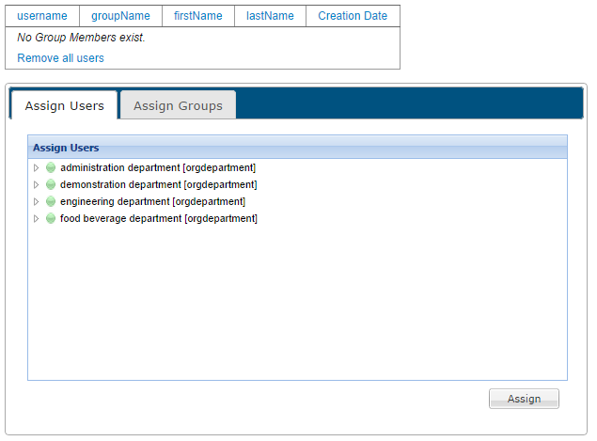
- To add an individual to the group click on the “Assign Users” tab.
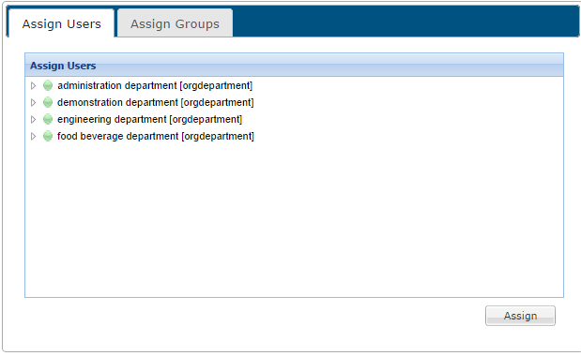
- Locate the participant you wish to add and check the box next to their name, and then click “Assign”.
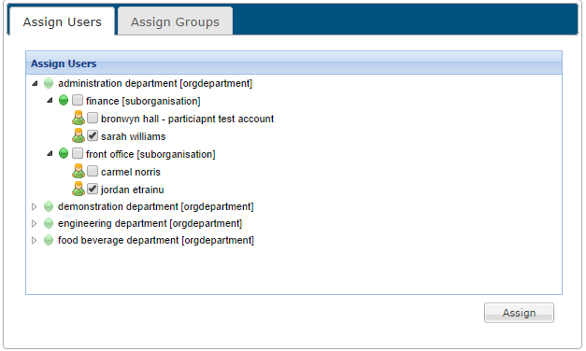
Click on the arrows beside the department and sub-orgs to reveal a list of participant names.
Ensure there is a tick beside the participant you want to add to the group.
Ensure you are in the Assign Users tab.

Removing Participants from a Participant Group
There is no need to remove participants from the ‘Regions’ participant groups. When a participant has been archived from the system it will automatically remove that participant from the Regions Participant Group.
However, you will need to remove participants from the Store Managers, Sales Assistant, Head office Managers, Head Office Non Managers and All Store Employees groups. To do this, please follow the steps below.

Deleting a participant from the Store Managers, Sales Assistant, Head office Managers, Head Office Non Managers or All Store Employees Participant group:

Once you have followed the steps on how to archive a participant above, please follow the steps below to remove the participant from the participant group.

- Click on “Participants” in the top menu bar – a drop down menu will appear.
- Click on “Grouping Participants” in the drop down menu.
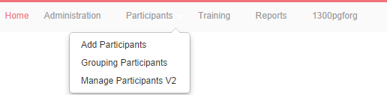
- Click on the Add icon next to the Manager, Head office, Assistant or All employees group that the archived participant is in.
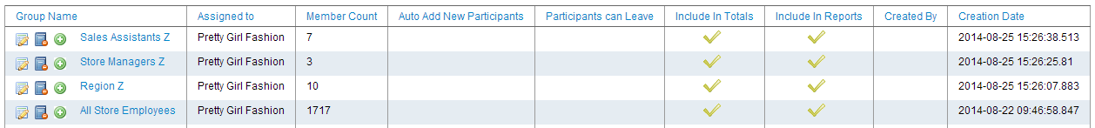
- Locate the participant – you can filter the list of participants by clicking on the First Name or Last Name column headings.
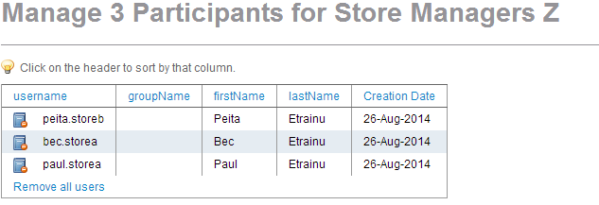
You can filter the list of participants by First Name or Last Name.
- Click on the Archive button to remove the participant from the participant group.
- A message will appear that reads “Are you sure you want to remove this group member?” – If you are sure then click “OK”.

Managing Training Groups

Creating Training Groups:

- Click on “Reports” in the top menu bar – a drop down menu will appear.
- Click on “Training Groups” in the drop down menu.
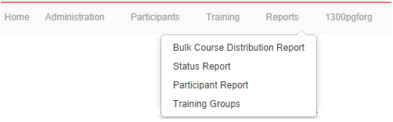
- Create a name for your group and type it in “Group Name”. Ensure “Courses” is selected in the drop down box. If you don’t want the training group visible to all administrators you need to make sure “Private” is ticked. Click “Add Group” once you have created a name.
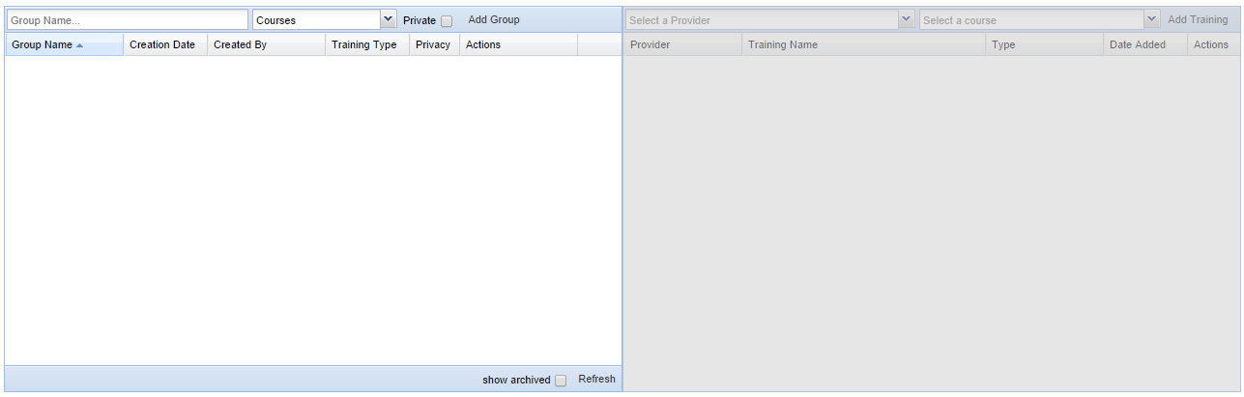
Tick if don’t want other administrators to see the group
Leave as Courses
Enter in Group Name
- Once you have click add group you should see the Group show up in the box below.
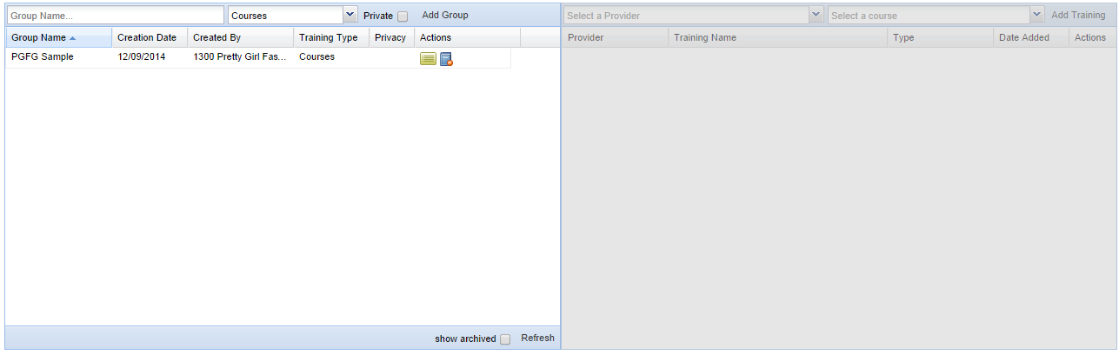
- Now you need to add the training modules you would like in your group. Click on your training group and the right hand side will become available for you to add training.
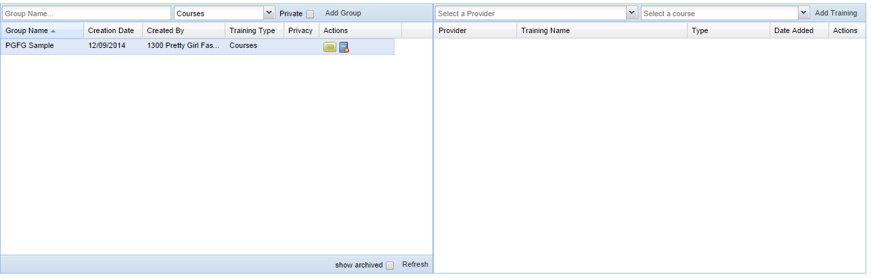
- On the right hand side select the “Provider” that the courses you wish to add sit under.
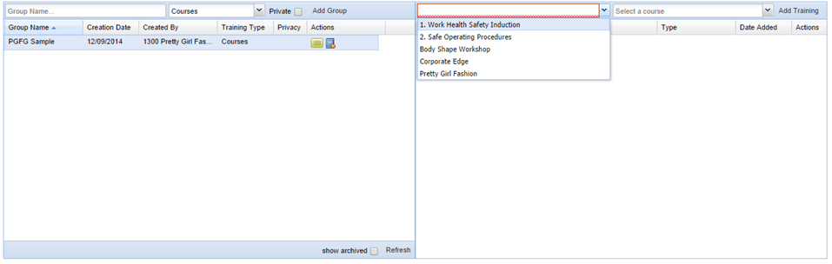
Select the Provider
- Select the “Course” you would like to add and then click “Add”.
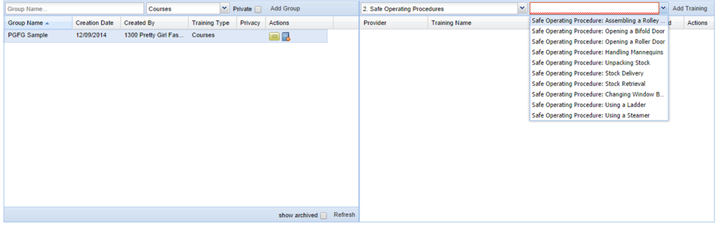
Select the Course/Module
- You will get a message “Successfully added training to group” click ok.
- The course has been allocated to the group.
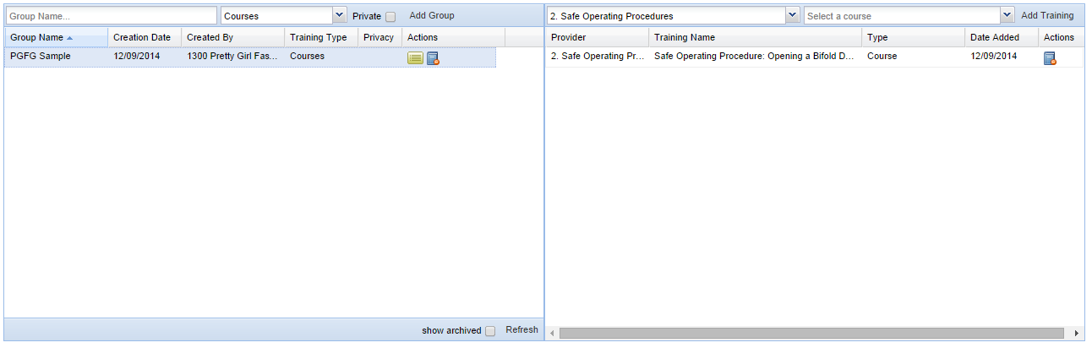
- Follow from step 6 to add more training to the group.

Removing Courses from Training Groups:

- Click on “Reports” in the top menu bar – a drop down menu will appear.
- Click on “Training Groups” in the drop down menu.
- Select the training group that you want the course to be deleted from.
- Find the course you want to remove and click the Archive button under action to remove the training.
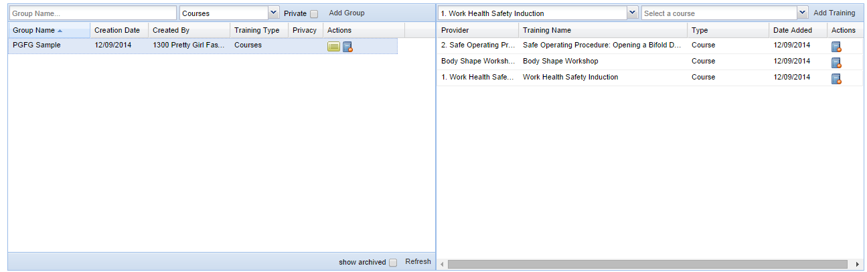
- The training has now been removed.

Archiving Training Groups:

- Click on “Reports” in the top menu bar – a drop down menu will appear.
- Click on “Training Groups” in the drop down menu.
- Find the training group you would like to archive and click the archive button under actions to archive the group. 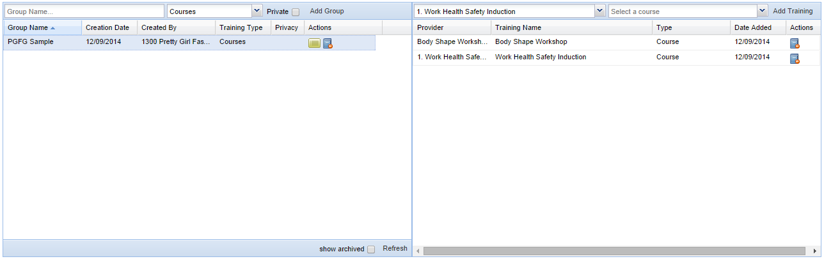
- You will get the message “Are you sure you want to archive this report group? Click ”Ok”
- You will also get another message “Successfully archived group” Click “Ok”

Viewing Reports
Training Status and Participant Reports: These reports will allow you to view module ‘completion status’ in specific areas of your business, including what types of courses are being delivered and how many.

Bulk Course Distribution Report: This report allows you to view all training that has been allocated as a bulk assign.

Training Status Report:
This report is based on the status of training assigned to participants across your business.

- Click on “Reports” in the top menu bar – a drop down menu will appear.
- Click on “Status Report” in the drop down menu.
- Select a ‘Group Type’:
  - Entities (Pretty Girl Fashion is default for your organisation)
  - Participant Groups (Regions or Individual)

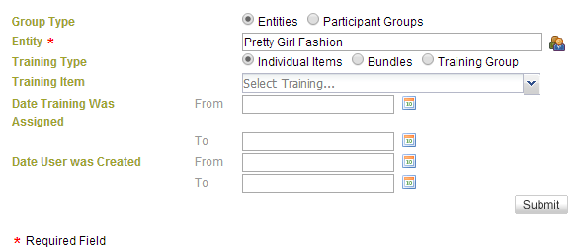
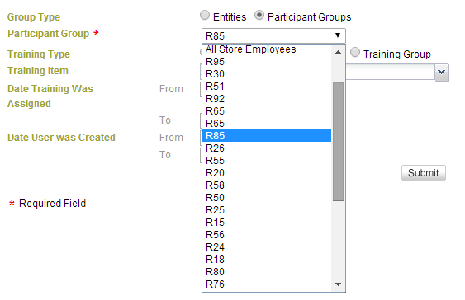
- The ‘Training Type’ has 3 variables – select 1 of the 3 available filters:
  - Individual Items (individual training module – you may only select 1 module)
  - Bundles (any group of courses that have been packaged together)
  - Training Group (a group of training you have created that you wish to report on)

- Select the training item from the drop down menu.

- The following filters are optional:
  - Date Training was Assigned
  - Date User was Created

- Click on “Submit” to display the results – you may export the report to a Microsoft Excel Spreadsheet if required.
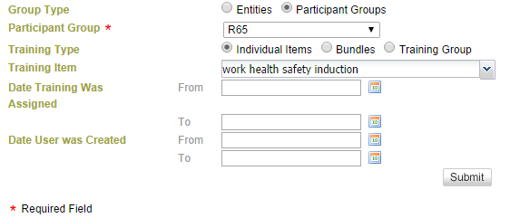
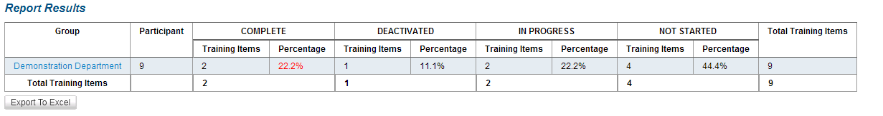
Anything in blue you can narrow done in the report to see who has completed and who hasn’t.

Participant Report:
- Click on “Reports” in the top menu bar – a drop down menu will appear.
- Click on “Participant Report” in the drop down menu.
- You may filter the report with the following options – you must chose at least 1 filter:
      - Report type:
        - Course (individual modules)
        - Bundle (modules that are grouped)
      - Participant Registered State
      - Post Code:
      - Individual Item or Training Group (by individual module or training group)
      - Participant Group
      - Course Status (choose options from drop down menu or leave as default to report on all training status)
      - Training Item Name (individual course name)
      - Bundle Name
      - Participants Name
      - Participant Created (date range)
      - Course Allocation (date range)
      - Course Completion (date range)
      - Participant DOB

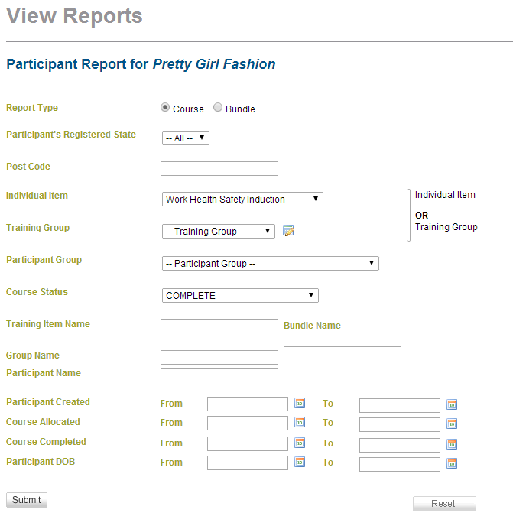
- Once you have selected your filters, click on “Submit” to generate the report – you may export the report to a Microsoft Excel Spreadsheet if required.
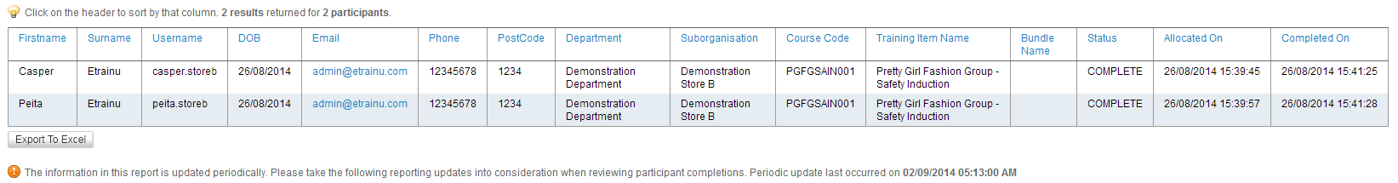

Bulk Course Distribution Report:
This report details how many bulk keys have been generated for employees for each training item. The graph shows how many in total were sent, how many were issued, how many were unsent and how many were activated.
    - Click on “Reports” on the top menu bar – a drop down menu will appear.
    - Click on “Bulk Course Distribution Report” in the drop down menu.
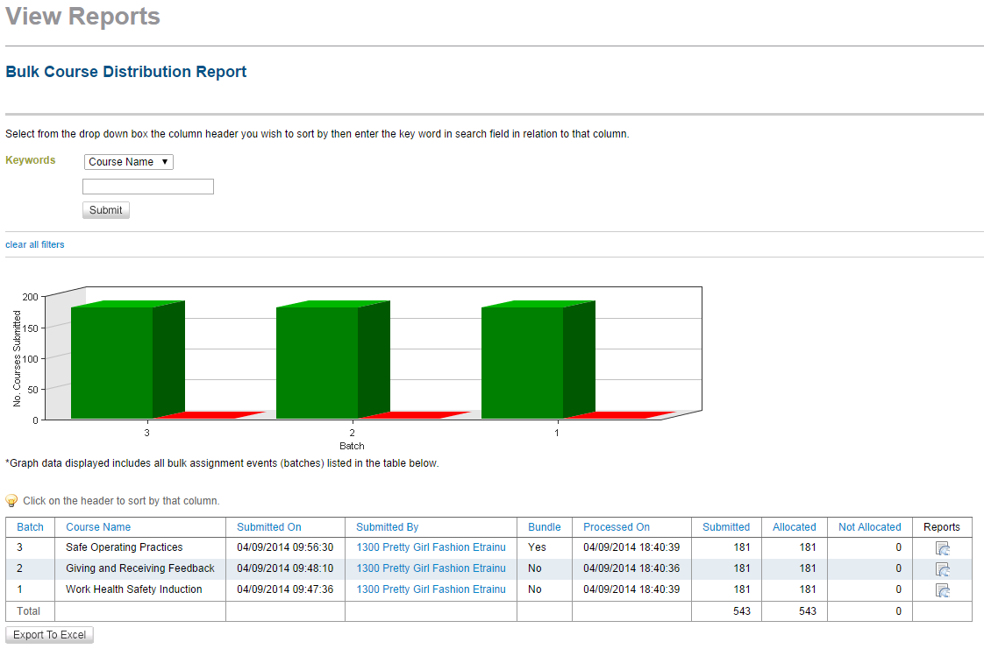
Click this link to view which employees the keys for the training item was sent to.
To sort through the information in the table you may select from the drop down menu which column header you wish to sort by, and then type in a keyword. Click “Submit”.

