Place your Clubs name here
Place your Clubs logo here.

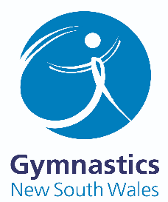
Complaints and
allegations record form template.

Use this template or adapt it to record complaints or allegations in your Club. Make sure that you keep this record in a safe and secure location, so that should it be required by DCJ and/or NSW Police as part of a formal investigation the details of the complaint can be provided. Include what is relevant to your organisation and add any other details if necessary.
This form should be used to record a suspicion, allegation or disclosure of child abuse, or a complaint of unacceptable behaviour.

Your name and position
Name of the child or young person involved
Name of person
making complaint
Name of person who the complaint was made against
Date that the allegation/complaint was made and recorded

- Nature of the complaint: include time, date, location, what happened and who was involved (this can include observations of the child’s behaviour).

- Details of any injuries and if the child received medical attention.

- Accurately record what the child said when describing what happened – use their exact words –
or record why you suspect abuse due to an indirect disclosure, such as a drawing or observed behaviour.

(In the case of an allegation of abuse, formal investigations and interviews will be carried out by DCJ and/or NSW Police. You must record what the child has said but unless it is your role to investigate, you should not interview the child.)

- Details of anyone who saw what happened.

- Does this complaint indicate the possibility of child abuse, such as physical abuse, psychological or emotional abuse, sexual abuse, or neglect?
Yes No

- Who did you make a report to?
NSW Police
DCJ via ChildStory
DCJ via 132 111
OCG Reportable Conduct Directorate
Internal reporting obligations (name the relevant department or person)
Other (name them)

- People spoken to in relation to the matter (describe who was spoken to and why they were spoken to about the matter – include police officers, DCJ staff, OCG staff and anyone else you spoke to).

Date(s):

For further assistance you can contact integrity@gymnsw.org.au

